**TAB 1 - ABOUT THE COLLEGE**

Srinivas University, Institute of Port Shipping and Supply Chain Management is a constituent of Srinivas University.

Port Shipping and Supply Chain Management Careers are among the most challenging, interesting and exciting jobs available for those with an undergraduate degree and also opens the door to career possibilities both in India and abroad.

The college encourages the study of Port Shipping and Supply Chain Management related to the industry. This also includes supervising routine operations undertaken sector.

Institute has signed **MOU with New Mangalore Port Authority (NMPA) and Mormugao Port Authority (MPA)** for student’s Internship, Training, Postings and Placements

**About Port, Shipping Management and Logistics**

Port and shipping management are the two odds and ends of logistics that represents a momentous role in international trade and commerce. A special thanks to globalization and enticement of sea routes, more and more companies are embracing the ideologies of port management.

But what’s the use of management and young graduates in this field? How can they put their analytical skills to use in the dull environment of transporting goods over the sea?

The answer to that is quiet simple. Port and shipping management requires more of the brain than the hands for lifting the freight. Imagination and inventiveness are the challenges that the young graduates strive for and this area demands the same.

In the shipping industry, you have to organize, supervise and get the ports functioning through

* Synchronizing deliveries with ships
* Handling the ship and logistics operations
* Marketing and developing port
* Enforcing security initiatives and
* Health management

As righteously quoted by Ethan Zuckerman,

So what better platform can you possibly have to show your creativity? And what better path other than BBA & ‘MBA can you possibly have to improve your skills?

**About Logistics and Supply Chain Management**

During the 1990s, many manufacturers and service

providers sought to collaborate with their suppliers and

upgrade their purchasing and supply management func-

tions from a clerical role to an integral part of a new

phenomenon known as supply chain management. Since

this aspect of supply chain management primarily fo-

cuses on the purchasing and supply management func-

tions of industrial buye

Over the past decade, the traditional purchasing and logistics functions have evolved into a broader strategic approach to materials and distribution management known as supply chain management. The development of supply chain management from two separate paths that eventually merged into the modern era of a holistic and strategic approach to operations, materials and logistics management. In addition, this clearly describe supply chain management how important it is in the Economic world.

Supply Chain Management is a network of facilities that produce raw materials, transform them into intermediate goods and then final products, and deliver the products to customers through a distribution system. The management of the supply chain and the roles of various actors involved differ from industry to industry and company to company. As a result Supply Chain Management (SCM) has become a vital issue for manufacturers, professionals and researchers. It is felt that to manage the supply chain effectively entire structure of supply chain must be understood properly. Subjects provide the reader a complete picture of port and shipping operations along with supply chain management through a systematic functions by step-by-step approach for understanding a complete picture.

Srinivas University situated in the heart of the city having its own identity in the field of higher education to provide better facilities to the students to reach better job opportunities around the globe.

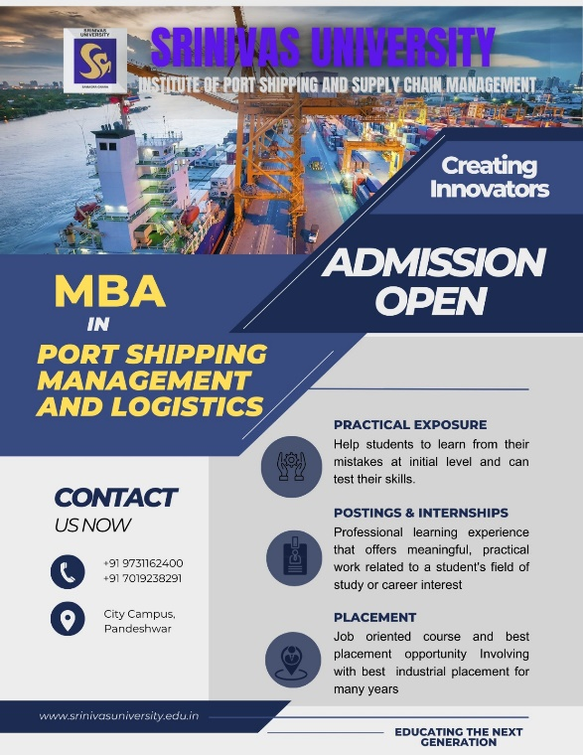 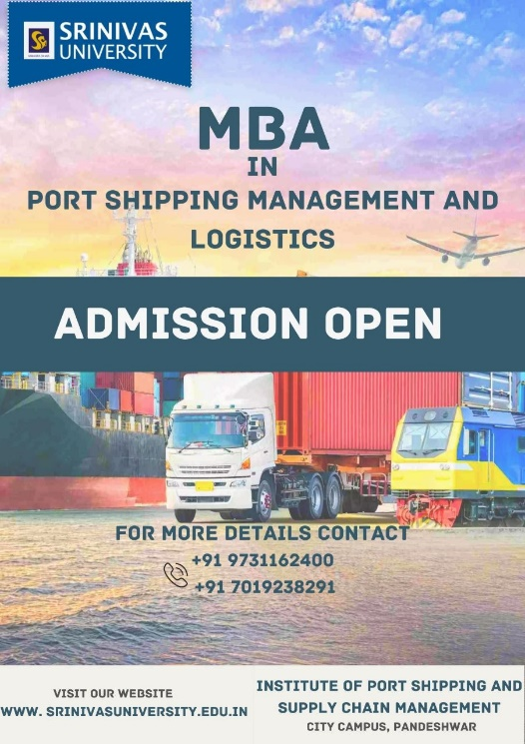

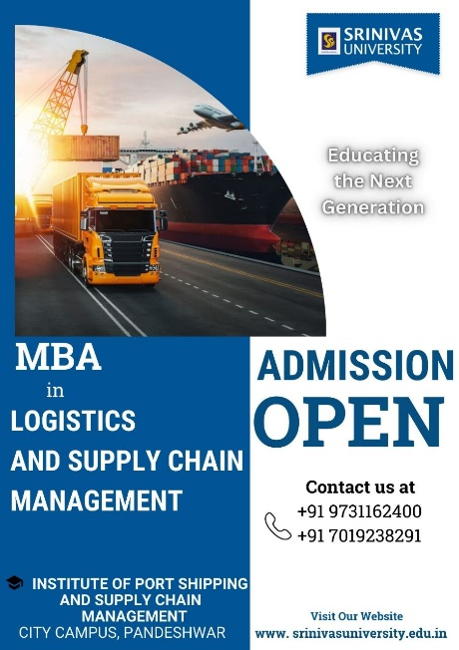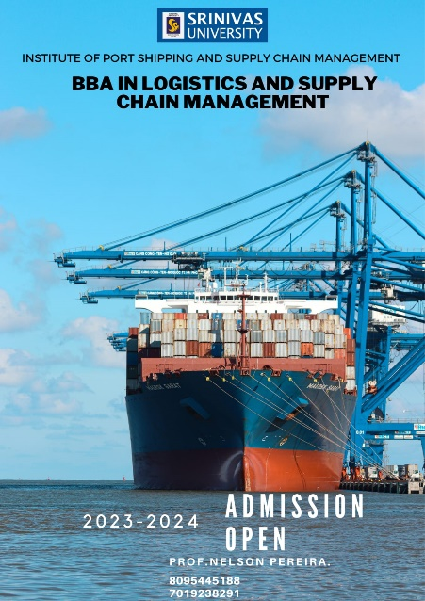 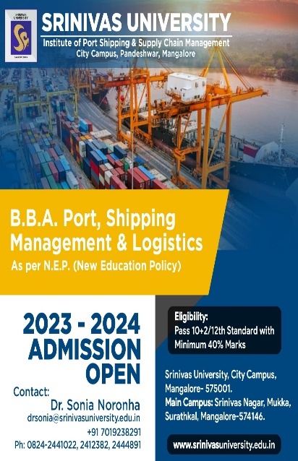

**SRINIVAS UNIVERSITY ADMINISTRATIVE OFFICE**

G.H.S. Road,

Mangalore – 575 001, INDIA

The promoting body “A. Shama Rao Foundation Trust” has its Administrative Office at G.H.S. Road, Mangalore.

**(google map to be included )**

**SRINIVAS UNIVERSITY CITY CAMPUS**

Pandeshwar

Mangalore – 575 001, INDIA

(Spread over 1.5 Acres 1,50,000 Sq. Feet Built-up Area)

**TAB 2 – COURSES**

***UNDERGRADUATE***

BBA - Port Shipping Management and Logistics

BBA - Logistics and Supply Chain Management

***POSTGRADUATE***

MBA - Logistics and Supply Chain Management

**Course Fees Structure**

***UNDERGRADUATE***

BBA - Port Shipping Management and Logistics

|  |  |  |
| --- | --- | --- |
| Course | Karnataka | Non Karnataka |
| BBA - Port Shipping Management and Logistics | 211000 | 334000 |

BBA - Logistics and Supply Chain Management

|  |  |  |
| --- | --- | --- |
| Course | Karnataka | Non Karnataka |
| BBA - Logistics and Supply Chain Management | 211000 | 334000 |

***POSTGRADUATE***

MBA - Logistics and Supply Chain Management

|  |  |  |
| --- | --- | --- |
| Course | Karnataka | Non Karnataka |
| MBA - Logistics and Supply Chain Management | 425500 | 305500 |

**TAB 3 – FACULTY MEMBERS**

**Faculty Details – Teaching and Non-Teaching**

|  |  |
| --- | --- |
| **FACULTY NAME** | **PHOTO** |
| Name: Dr. Sonia Delrose Noronha  Designation: Professor  Dean – Institute Of Port Shipping And Supplychain Management (IPSSM) |  |
| Name: Mr. Sagar Srinivas  Designation: Assistant Professor  HOD – pg department |  |
| Name: Mr. Nelson Pereira  Designation: Assistant Professor  HOD – ug department |  |
| Name: Mrs. Meghashree  Designation: Assistant Professor |  |
|  |  |
| Name: Mrs. Bhavya. K. N  Designation: Assistant Professor | C:\Users\ASUS\Downloads\8ae46298-589b-425e-b69a-41b07ee375b4.jfif |
| Name: Mrs. Souparnika  Designation: Assistant Professor | C:\Users\ASUS\Downloads\Souparnika.jpg |
| Name: Mrs. Akshatha Eva Sampson  Designation: Assistant Professor | C:\Users\ASUS\Downloads\002.jpg |
| Name: Ms. Shwetha P Bhat  Designation: Assistant Professor | C:\Users\ASUS\Downloads\001.JPG |

**Rank Holders For Under Graduate and Post Graduate Courses**

Srinivas University, Mangalore has announced the list of Rank Holders of BBA Under Graduate Degree Examinations held during the academic year

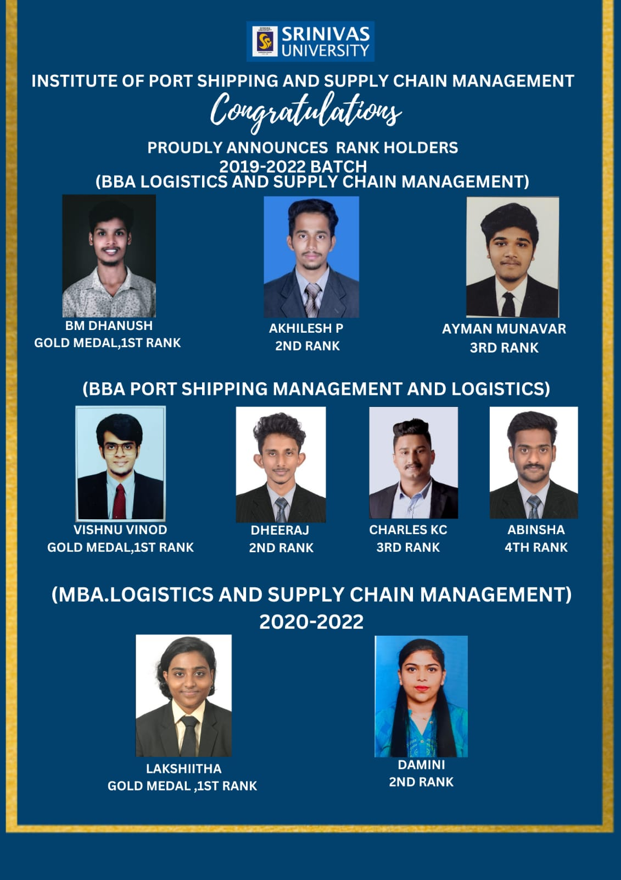

**TAB 4 – PLACEMENT**

**SRINIVAS UNIVERSITY**

**Institute of Port Shipping and Supply Chain Management**

|  |  |  |
| --- | --- | --- |
| Adithya Madhukumar    BBA Logistics & Supply Chain Management  Amogha Shipping Agency | Akhilesh Sithangoli    BBA Logistics & Supply Chain Management  Ganesh Shipping  Jindal Steel Works | Nabeel CH    BBA Logistics & Supply Chain Management  Amogha Shipping Agency |
| Adith V. O.  BBA Logistics & Supply Chain Management  Cochin Port Trust | Shivarathnaprasad    BBA Logistics & Supply Chain Management  Amogha Shipping Agency | Dulfukkar    BBA Logistics & Supply Chain Management  CENTRAL Future Retail |

|  |  |  |
| --- | --- | --- |
| Joel James  BBA Logistics & Supply Chain Management  Cochin Port Trust | Mohammed Mufeed    BBA Logistics & Supply Chain Management  Mangalore CENTRAL Future Retail | Akash S Panikar    BBA Logistics & Supply Chain Management  Cochin Port Trust |
| Adhish M  BBA Logistics & Supply Chain Management  Amogha Shipping Agency | Ayman Munawer Ahmed  BBA Logistics & Supply Chain Management  Fils International Freight and Logistics Services | Muhammed Sahshad Manjoor  BBA Logistics & Supply Chain Management |

|  |  |  |
| --- | --- | --- |
| Fahad Moideen    BBA Logistics & Supply Chain Management  New Mangalore Port Authority | Omarul farooq p a  BBA Logistics & Supply Chain Management  New Mangalore Port Authority | Anas Bin Ayyoob  BBA Logistics & Supply Chain Management  Silver Pumps Middle East LLC Dubai, UAE |
| Rajmohan  BBA Logistics & Supply Chain Management  Capex Cashews | Abhinav Chandran    BBA Logistics & Supply Chain Management  Capex Cashews | Abhishek Mohan    BBA Logistics & Supply Chain Management  VRL Logistics |

|  |  |  |
| --- | --- | --- |
| Harshan TV    BBA Logistics & Supply Chain Management  Amogha Shipping Agency | Sidhikul Akbar    BBA Logistics & Supply Chain Management  Cochin International Container Freight Station (CICFS)  Kerala State Industrial Enterprises Ltd. | Anirudh    BBA Logistics & Supply Chain Management  FLIPKART |

|  |  |  |
| --- | --- | --- |
| Charles K. C.  BBA Port and Shipping  Shri Ganesh Shipping Agency  Jindal Steel Works | Sulthan Sabeel Khan  BBA Port and Shipping  Bafco International Shipping And Logistics Company Ltd. |  |

**TAB 5 – INTERNSHIP**

**INTERNSHIP**

**PORT SHIPPING MANAGEMENT & LOGISTICS**

|  |  |
| --- | --- |
| **STUDENT DETAILS** | **PHOTO** |
| NAME: ABHIJITH SHANKAR  ORGANISATION NAME: NMPA | ABHIJITH SHANKAR |
| NAME: ABHINSHA NADIR  ORGANISATION NAME: NMPA | ABHINSHA NADIR |
| NAME: ADARSH U  ORGANISATION NAME: NMPA | ADARSH U |
| NAME: ADIL HYDROSE P H  ORGANISATION NAME: NMPA | ADIL HYDROSE P H |
| NAME: AKASH K BIJO  ORGANISATION NAME: NMPA | AKASH K BIJO |
| NAME: ANIKETH V  ORGANISATION NAME: NMPA | ANIKETH V |
| NAME: ASJOE SHAJAN  ORGANISATION NAME: NMPA | ASJOE SHAJAN |
| NAME: ASWIN A S  ORGANISATION NAME: NMPA | ASWIN  A S |
| NAME: ASWIN PRADEEP  ORGANISATION NAME: NMPA | ASWIN PRADEEP |
| NAME: CHARLES K C  ORGANISATION NAME: NMPA | CHARLES K C |
| NAME: DEERAJ  ORGANISATION NAME: NMPA | DEERAJ |
| NAME: DHANUSH K  ORGANISATION NAME: NMPA | DHANUSH K |
| NAME: JOEL GORGE FANCIS  ORGANISATION NAME: NMPA | JOEL GORGE FANCIS |
| NAME: K BENJAMIN JHON SIMON  ORGANISATION NAME: NMPA | K BENJAMIN JHON SIMON |
| NAME: MAJESH M  ORGANISATION NAME: NMPA | MAJESH M |
| NAME: MOHAMMED THOUFEQ V B  ORGANISATION NAME: NMPA | MOHAMMED THOUFEQ V B |
| NAME: MUHAMMED FAIZAM  ORGANISATION NAME: NMPA | MUHAMMED FAIZAM |
| NAME: MUHAMMED SIRAJ K K  ORGANISATION NAME: NMPA | MUHAMMED SIRAJ K K |
| NAME: RAGUL A  ORGANISATION NAME: NMPA | RAGUL A |
| NAME: RANJITH DEVADIGA  ORGANISATION NAME: NMPA | RANJITH DEVADIGA |
| NAME: SHEBIN K  ORGANISATION NAME: NMPA | SHEBIN K |
| NAME: SHIBIN K S  ORGANISATION NAME: NMPA | SHIBIN K S |
| NAME: SULTHAN SABEEL KHAN  ORGANISATION NAME: NMPA | SULTHAN SABEEL KHAN |
| NAME: THANVEER ISHAQ  ORGANISATION NAME: NMPA | THANVEER ISHAQ |
| NAME: VISHNU VINOD  ORGANISATION NAME: NMPA | VISHNU VINOD |

**INTERNSHIP LIST**

**PORT SHIPPING MANAGEMENT & LOGISTICS**

|  |  |
| --- | --- |
| **STUDENT DETAILS** | **PHOTO** |
| NAME: Abhiram R Iyenger  ORGANISATION NAME: Ganesh Shipping | ABHIRAM R IYENGER |
| NAME: Anandhu V  ORGANISATION NAME: Byepore Port ,Calicut | ANANDHU V |
| NAME: Vinayak  ORGANISATION NAME: Ganesh Shipping | VINAYAKA |

**Prospectus and Brochure Newsletter**

**Career Prospects of Shipping and Logistics**

* Supply Chain Analyst
* Logistics Analyst
* Logistics Manager
* Customer Service
* Production Planner
* Inventory Manager
* Purchasing Marine Officer
* Marine Co Ordinate
* Bulk Carrier Associate
* Customs Compliance
* Sales order planner
* Production planner
* International logistics

**TAB 6 – MORE**

**NEWS AND EVENTS**

**REPORT ON INDUSTRIAL VISIT**

Srinivas University – Institute of Port Shipping and Supply Chain organized One day

Industrial Visit for the First year BBA students to NMPT, Mangalore on May 05/05/22.

During the visit, students got practical exposure and also got to know the functions of NMPT from Mr. Arun kumar and Mr.Dinakar. Dr.Sonia Naronha accompanied students. This industrial visit is conducted under the guidance of Dean. Dr.Sonia Noronha.

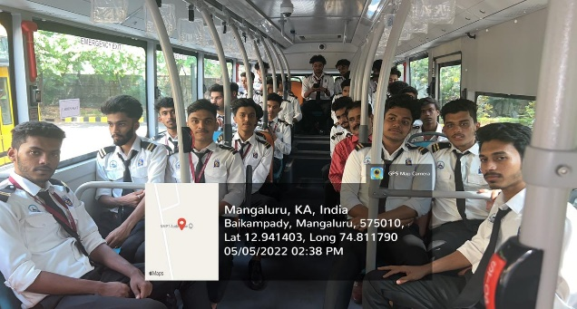 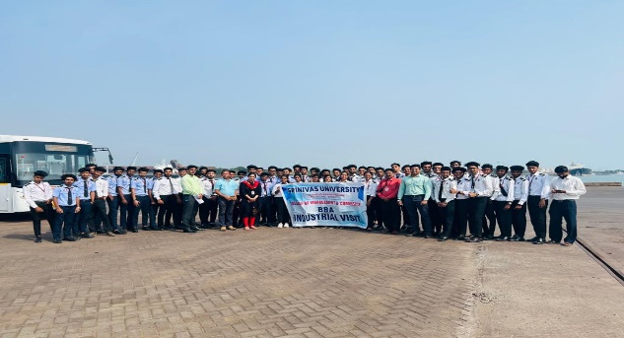

**REPORT ON INDUSTRIAL VISIT**

Srinivas University – Institute of Port Shipping and Supply Chain organized One day Industrial Visit for the II year BBA students to Deccan Plast, Mangalore on April 29 th 2022. During the visit, students got practical exposure and also got to know the functions of Deccan Plast from Mr Nizamuddin. Prof. Shwetha Bhat and Prof. Vinutha H K accompanied students. This industrial visit is conducted under the guidance of Dean. Dr. Sonia Noronha.

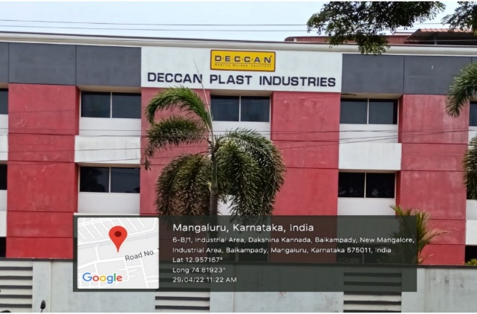 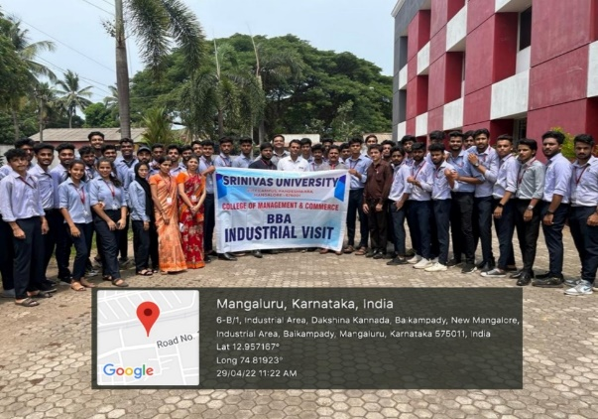

**REPORT ON INDUSTRIAL VISIT**

Srinivas University – Institute of Port Shipping and Supply Chain organized one day

Industrial Visit for the First year BBA students to Pilikula Nisargadhama and cottage

Industry, Mangalore on February 24/02/2022. During the visit, students got practical

exposure and also got to know the functions of cottage industry from Mr. Daya sagar. Prof.

Aneesh and Prof. Chirag accompanied students. This industrial visit is conducted under the guidance of Dean Dr. Sonia Noronha.

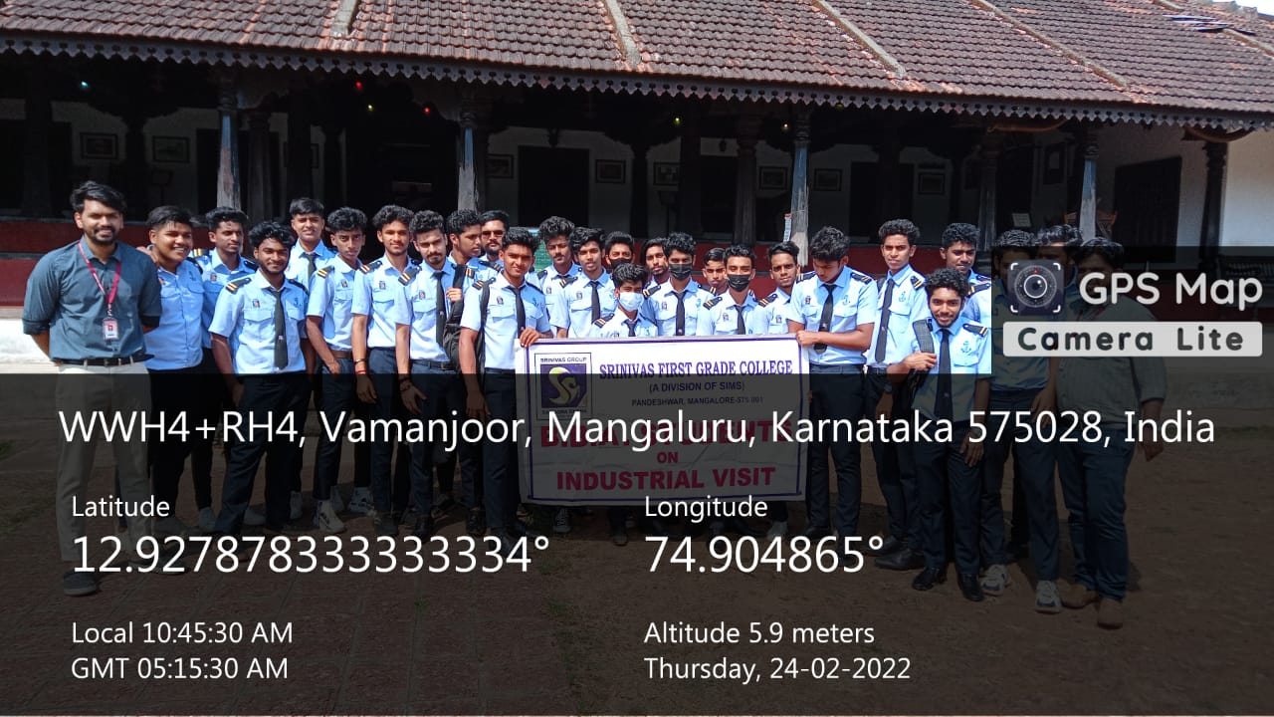

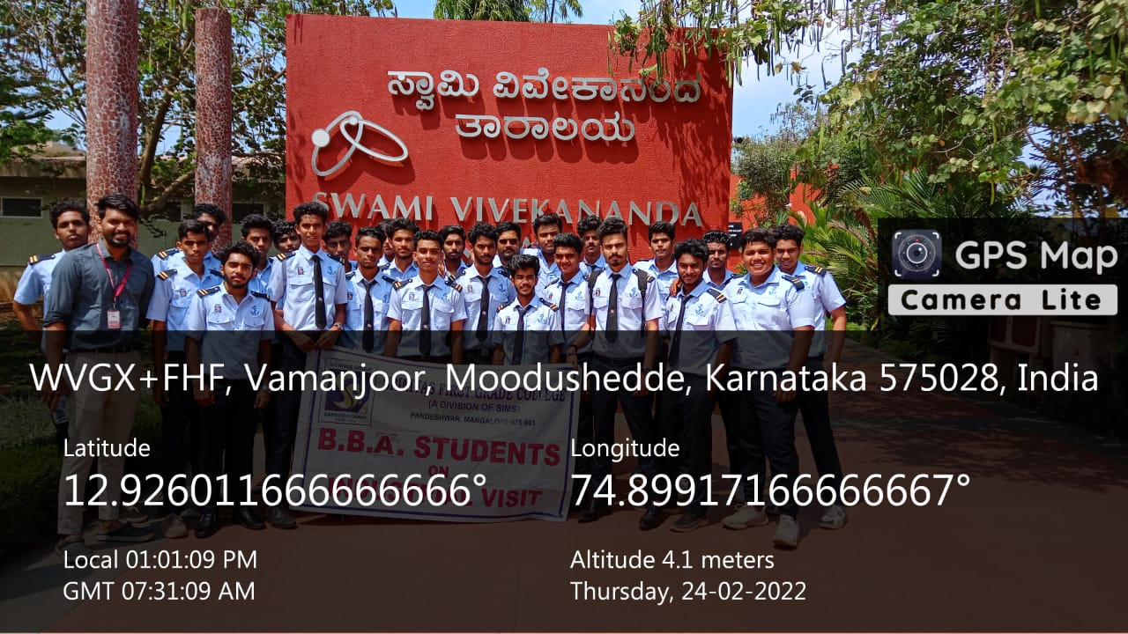

**SRINIVAS UNIVERSITY**

**Institute of Port Shipping and Supply Chain Management**

December 2021

Report on Fresher’s Day

On December 02, Srinivas University (SU), Pandeshwar organized its Fresher’s Day on the college premises. Dr. P. S. Aithal, Vice Chancellor Srinivas University, Dean Dr. Sonia Noronha, Mr. Omarul Farooq, Ms. Greeshma , Mr Charles K C and Mr. Anirudh, Student Cultural Co-ordinators were present. The purpose of the Fresher’s Day was to make every new students feel connected as an integral part of the BBA Family.  Cultural programmes followed thereby with various types of dance forms, songs and even Games were also conducted for the freshers.

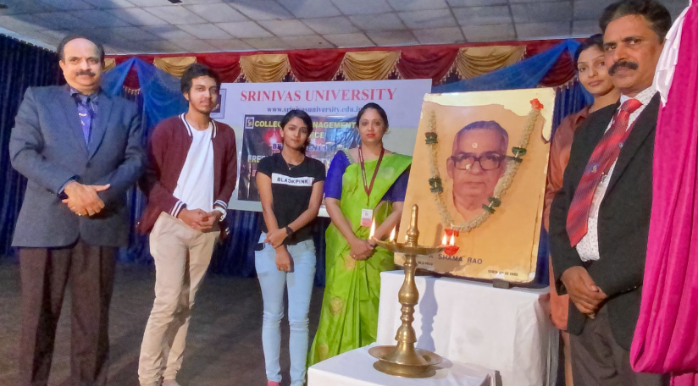 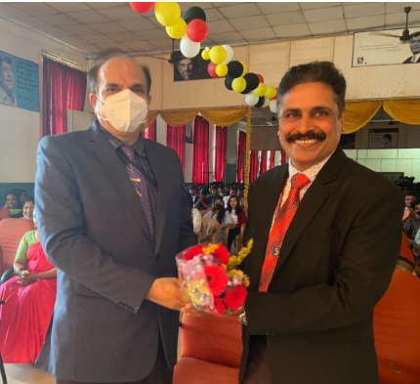

**NATIONAL SERVICE SCHEME (NSS)**

**ENERGY CONSERVATION PLEDGE**

On 14th December 2021, as a part of celebrating National Energy Conservation Day,Institute of port shipping and supply chain, Srinivas University, has organized

An Online pledge campaign at 11.00 am for BBA students to take energy conservation pledge. We took the pledge through Teachmint virtual platform in two consecutive sessions in order to accommodate the students of both BBA. Nearly 100 students were participated in taking pledge.

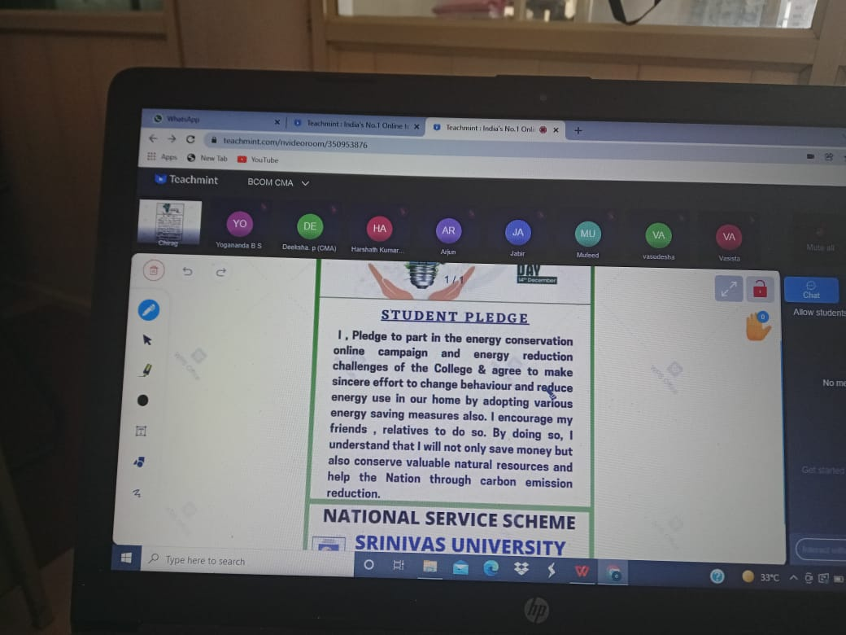Our Students were guided by Prof. A K Anish and Prof. Shilpa .K Coordinator of NSS wing. The programme was successfully completed due to constant support Dean Dr. Sonia Noronha of Institute of port shipping and supply chain.

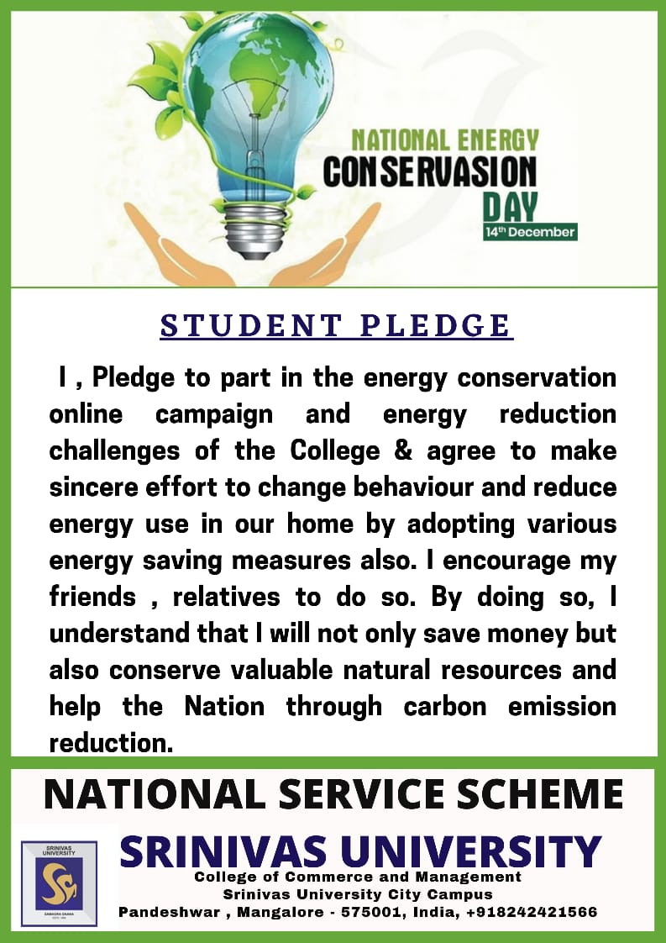**Report On Workshop “Introduction to Corporate Social Responsibility”**

**Date: 05/12/2021**

The Srinivas University –BBA Department organized workshop on Logistics and Supply Chain, topic “Introduction to Corporate Social responsibility” for First Year Honors and Logistic and Supply Chain Management students by Mr. Steevan D’souza on 04/12/2021 at 10:00 AM to 11.45 AM. He explained with example how the CSR activities done in India and its importance. Introduction of resource person and welcome done by Ms Harinakshi. Vote of thanks by Prof. Meghashree guest Lecture Coordinator Dr. Sonia Noronha Dean of Institute of port shipping and supply chain, Srinivas University.

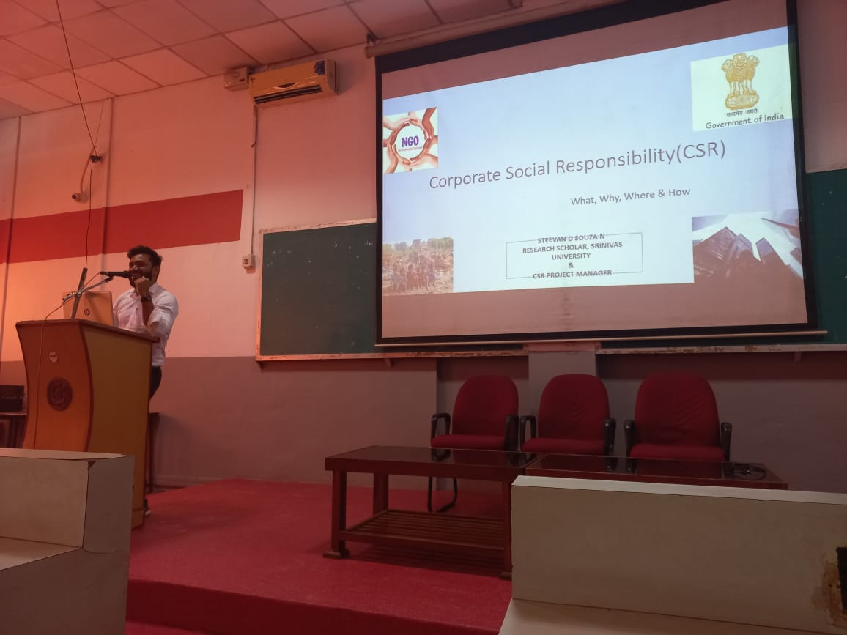 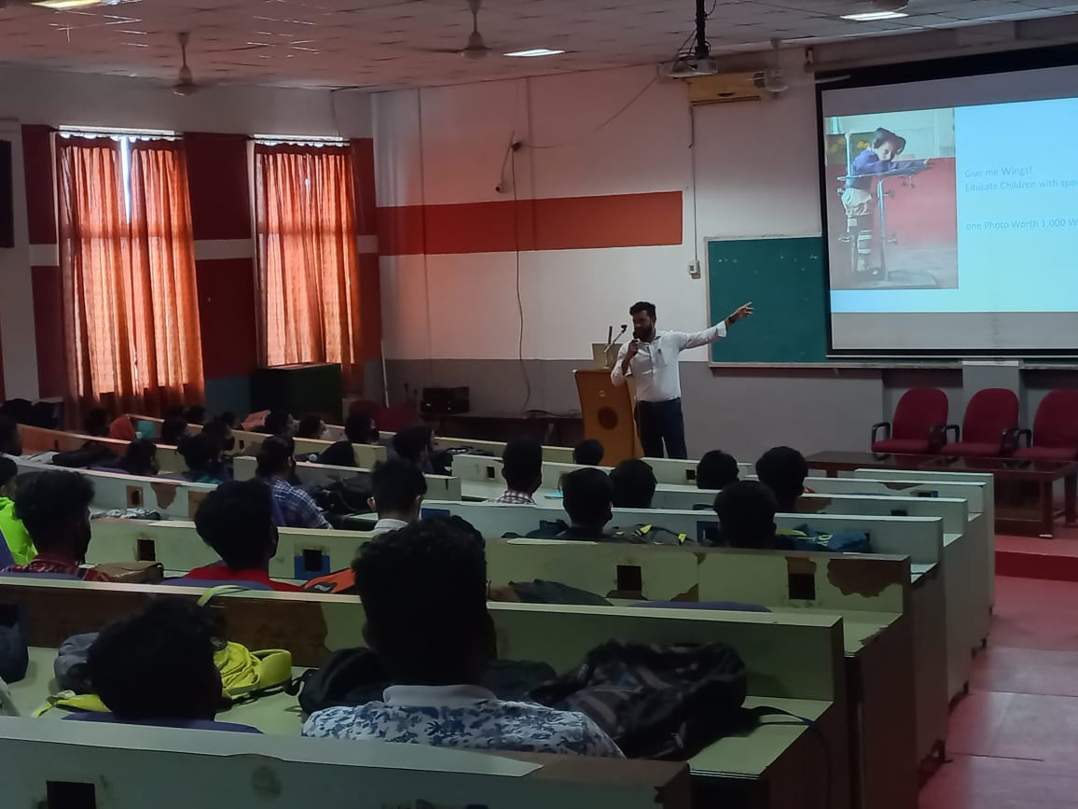

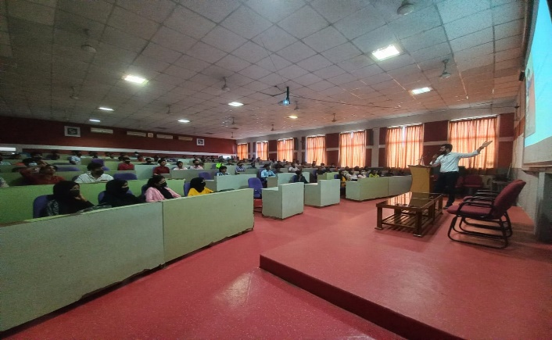 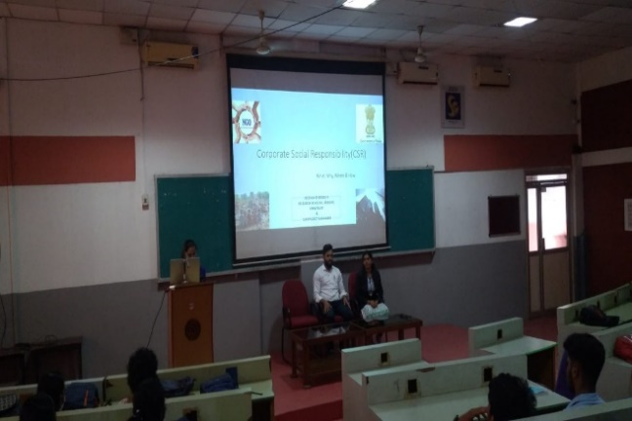

**SRINIVAS UNIVERSITY**

**City campus, Pandeshwara, Mangalore**

**Brand Management Exhibition**

Srinivas University - Institute of Port Shipping and Supply Chain Management, Srinivas University, has organized “Brand Management Exhibition – Competition” for BBA Port, Honors and BA Journalism students. Students identified well-known brands and highlighted the elements of Brand Identity. This activity was organised as a part of experimental learning under the guidance of Dr. Sonia Noronha Dean CMC.

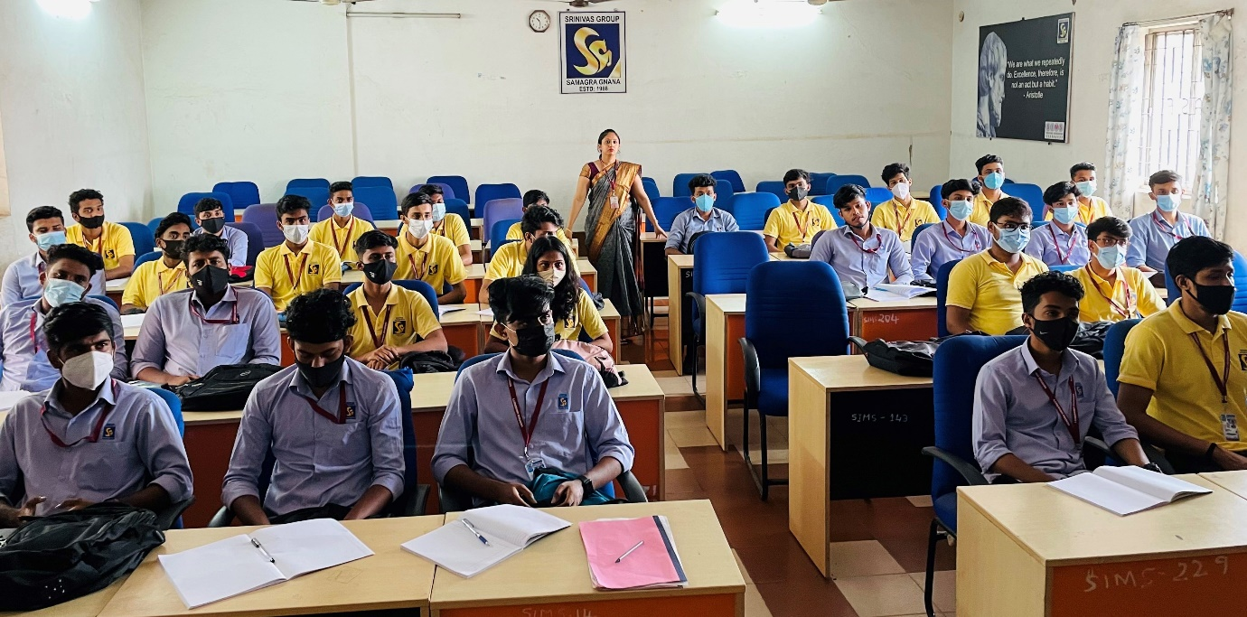

Winners:

I Prize: Mr. Swaroop Suvarna, Mr. Rakshan Kumar, Mr. Kritik L & Mr. Prinson D'souza

II Prize: Mr. Nithesh Kumar, Mr. Marwan, Mr. Shaikh Imroz & Mr. George Johnson

III Prize: Mr. Abdul Vasih, Mr. Mohammed Afraz, Mr. Abdul Rahman & Mr. Sudhesh Kumar

III Prize: Mr. Jithin K, Mr. Vishnu Chandran, Mr. Vaisak M, Mr. Aswin Ayyappan & Mr. Abdul Kasim Ijaz

**GUEST LECTURE ON SOFT SKILL**

The department of Bachelor of Business Administration Logistic and Supply Chain Management organized a guest lecture on “Soft Skill and Personality Development” as a part of departmental activities of academic year 2021-22 on 12th January 2021. The lecture was delivered by Prof. Steeven D’Souza and Prof. Ren Trevor Dias, explained about how to develop Soft Skills and Personality required for Students Carrier Development for their future.

**SRINIVAS UNIVERSITY**

**City campus, Pandeshwara, Mangalore**

**Institute of Port Shipping and Supply Chain Management, Srinivas University**

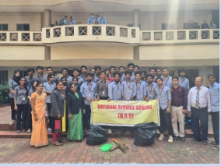 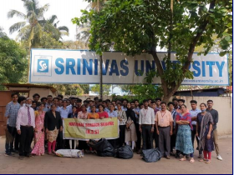

Campus cleaning by BBA

The UG Commerce Department of IMC, Srinivas University City Campus Pandeshwar had organised Campus Cleaning programme within the college premises at Pandeshwar on 3rd

February 2021

**FACULTY DEVELOPMENT PROGRAMME**

A Faculty Development Programme for faculties of Srinivas University was held on 20th, of March 2021 at Srinivas University City Campus and Srinivas University Mukka Campus. This FDP was conducted under the aegis of Centre for Faculty Training, Srinivas University on the topic ‘Srinivas University Faculty Responsibilities & How to Increase Annual Performance Indicator (API) Scores’. Dr. P.S. Aithal, Vice-chancellor, Srinivas University was Resource Person.

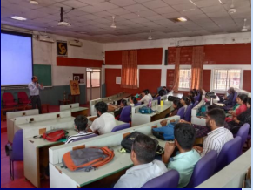

**SRINIVAS UNIVERSITY**

**CITY CAMPUS, PANDESHWARA, MANGALORE**

**Institute of Port Shipping and Supply Chain Management, Srinivas University, Has Organized Founders Day**

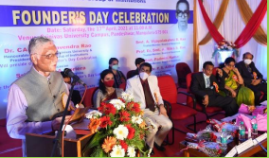

Founders Day Celebration of A. Shama Rao Foundation, Srinivas University and Srinivas Group of Institutions

Founder’s Day Celebration of A. Shama Rao Foundation, Srinivas University and Srinivas Group of Institutions was held on Saturday 17th April, 2021 at Srinivas University, City Campus, Pandeshwara, Mangalore. Mr. Allen CA Periera – Ex Chairman of Bank of Maharashtra was the Inaugurator and Chief Guest. In his inaugural address, he said Banking and Education are the two valuable pillars of society. Education prepares the society for the future and Banking enables society to achieve production and economic growth. The knowledge of life and the knowledge & skill for living is an integral part of education, a good education must provide these two things for students. Dr. CA. A. Raghavendra Rao., Chancellor of Srinivas University and President of the A Shama Rao Foundation, presided over the function. In his presidential remarks, he said that the success of growth goes to the teachers, their hard work and talent achieves to reach this level. Also, he said Srinivas Institution will be opening shortly in Bangalore.

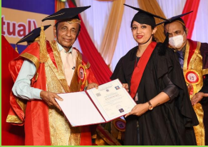

The Third Annual Convocation of Srinivas University had held on 17th April, 2021 at Srinivas University, City Campus, Pandeshwar, and Mangalore. Over 327 students comprising of 205 UG students and 114 PG students will be APRIL 2021 SRINIVAS UNIVERSITY 4 awarded the degree. The ranks including 16 Gold Medals, 29 UG, 16 PG students, 1 M. S., 1 Ph.D., 7 D. Sc., 2 D. Litt. (h.c.) degree had been awarded at the event. Dr. CA. A. Raghavendra Rao, Chancellor of Srinivas University has presided over the programme and administered the oath to the young graduates. Dr. P. S. Aithal – Vice Chancellor, presented Srinivas University Report. Dr. A. Srinivas Rao – Pro Chancellor, Srinivas University, welcomed the gathering. Dr. Anil Kumar – Registrar, Srinivas University delivered the vote of thanks. Mr. Rohan Fernandez of Srinivas University, College of Engineering and Technology hosted the event. Dr. Anil Kumar – Registrar, Dr. Srinivas Mayya – Registrar (Evaluation), Dr. Ajay Kumar Registrar (Development), Mr. Adithya Kumar – Registrar (Academic), Smt. Vijayalakshmi R. Rao, Prof. Smt. A. Mitra S. Rao – Trustee Members, Board of Governors were present on the occasion.

.

**SRINIVAS UNIVERSITY**

**City campus, Pandeshwara, Mangalore**

**Institute Of Port Shipping and Supply Chain Management, Srinivas University**



Online ‘Coastal and Marine Tourism in India’ competition held for Srinivas University

COVID-19 pandemic has changed education dramatically. The distinctive rise in online learning has kept students away from traditional classrooms but has enabled in reaching out to students from more effectively and efficiently. Keeping in mind the complete benefits of education during this pandemic BBA Port, Shipping Management and Logistics, College of Management and Commerce, Srinivas University on May 25 organised an online competition for Port, Shipping Management and Logistics students as part of its experiential learning pedagogy.

**Institute Of Port Shipping and Supply Chain Management, Srinivas University, has organized Mini Project - ‘Coastal and Marine Tourism in India’**

COVID-19 pandemic has changed education dramatically. The distinctive rise in online learning has kept students away from traditional classrooms but has enabled in reaching out to students from more effectively and efficiently. Keeping in mind the complete benefits of education during this pandemic BBA Port, Shipping Management and Logistics, College of Management and Commerce, Srinivas University organised an online competition for Port, Shipping Management and Logistics Students as a part of its experiential learning pedagogy on 25.5.2021.

Students had to prepare a mini project on the topic ‘Coastal and Marine Tourism in India’ Highlighting coastal events & attraction, Marine wildlife Tourism, Education, Marine protected areas, Fisheries, Water Sports & recreation and Cruise industry. This competition facilitated in Identifying and developing the creativity and innovation among the students. Students prepared the mini projects through digital mode. Students actively participated in this competition bringing back the joy of participation during this pandemic.

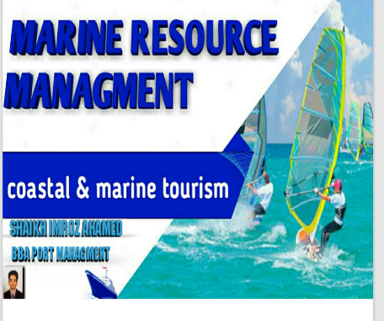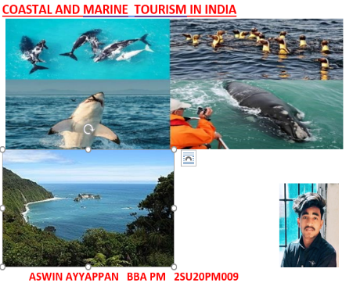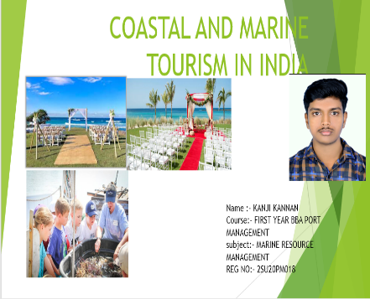

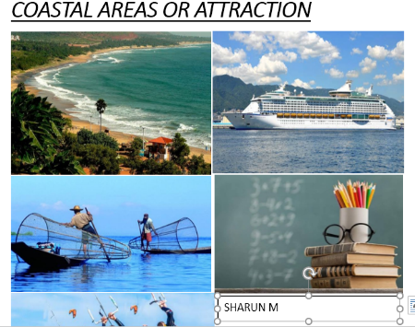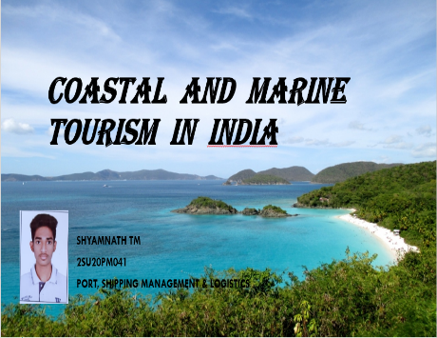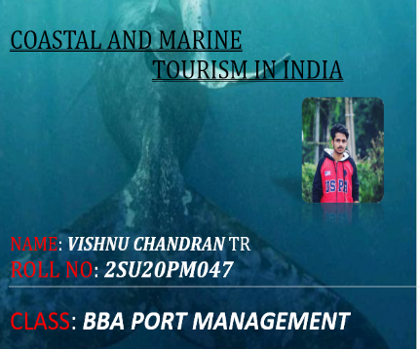

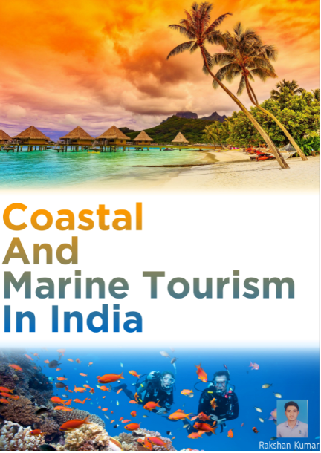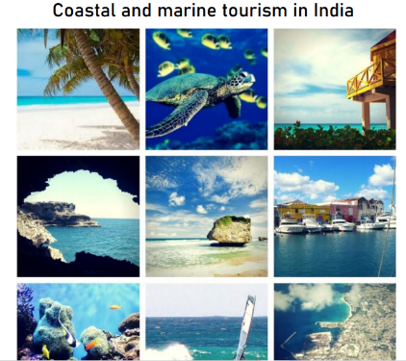

**Srinivas University BBA Port Shipping Management and Logistics observes International Yoga Day**

Srinivas University (SU) BBA Port Shipping Management and Logistics, College of Management and Commerce celebrated International Yoga Day 2021 with much enthusiasm and passion on the theme ‘Yoga for wellness – Yoga for Health at home'.

Yoga is a ray of hope against Covid-19 as said by our honourable Prime Minister Narendra Modi in his speech on International Yoga Day.

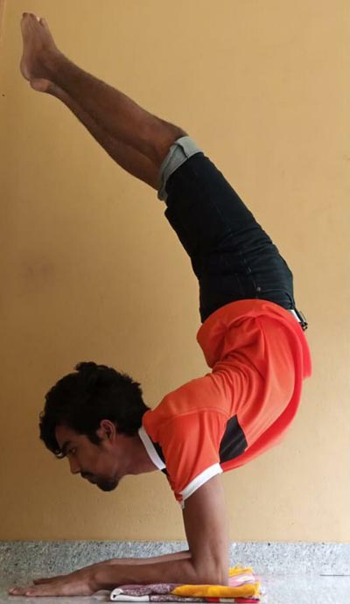 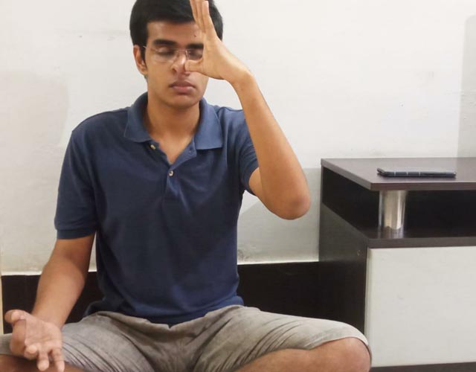

**WORLD ENVIRONMENT DAY 2021 AT SRINIVAS UNIVERSITY**

Institute of port shipping and supply chain , Srinivas University, has organized seed collection and online tree plantation drive on 05.06.2021with a slogan “Reimage, Recreate, restore” declared by United Nations a decade on Ecosystem Restoration. This drive created awareness related to environment and sustainable living. Lockdown imposed during pandemic did not stop the enthusiasm of students to conserve ecosystem, as students profoundly contributed by planting in their home garden. Online session was ended by learning the effects of global warming and by taking oath to prevent the environment from pollution.

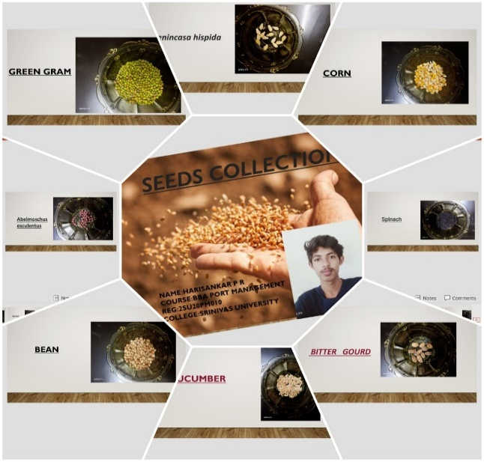 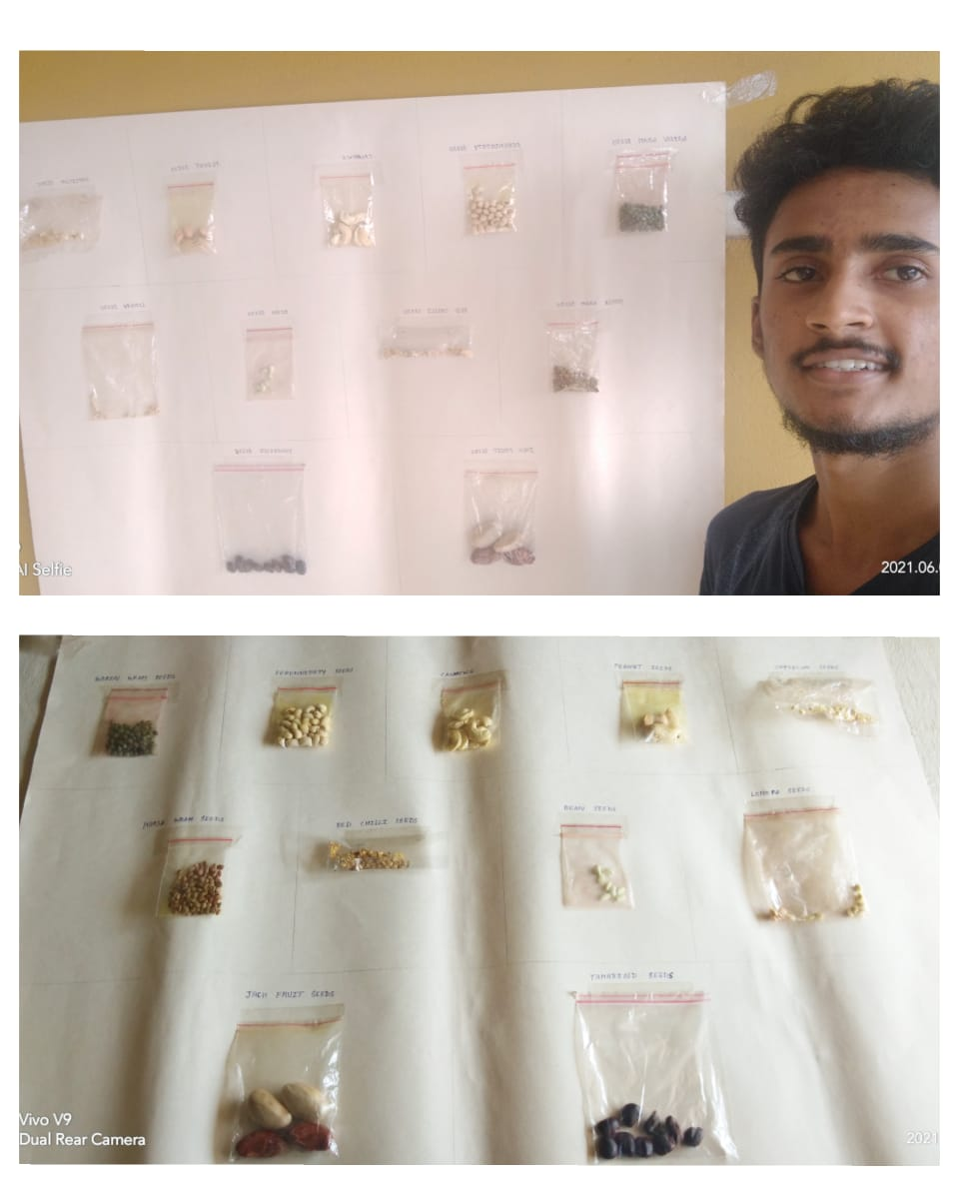

**Institute Of Port Shipping and Supply Chain Management, Srinivas University, holds online job Fair**

Srinivas University (SU), College of Management and Commerce organizes online job fair programme, professional resume writing training, competitive exam training and interview training workshops for students who will be completing their degree soon thereby making them future ready.

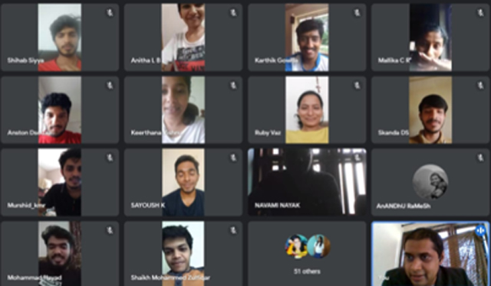

Skill Based Activities for Super Specialization Courses

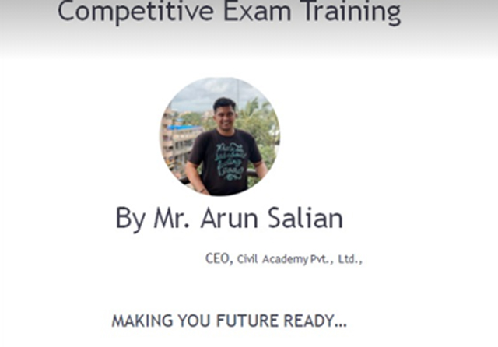 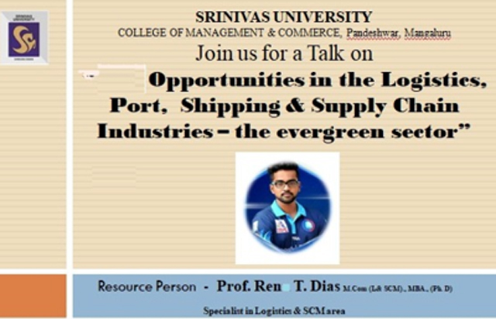

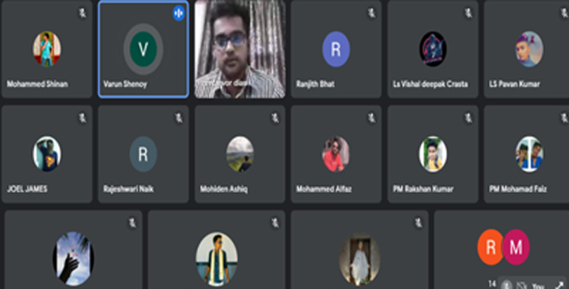

Keeping in mind the need to have students who are equipped with all the skills needed for getting good placements, the College of Management and Commerce organized several activities for its students of various courses – B.Com - Honours, B.Com ACCA, B.Com USA CMA, BBA - Logistics and Supply Chain Management, BBA Port, Shipping and Logistics Management, BBA Hospital Administration, BBA International Business, BBA Financial services, BBA – Hospital Administration and BBA – Public Administration with IAS training and MBA (Dual Specialization, Logistics and Supply Chain Management and M.Com (dual specialization).

The students learnt how to create a professional resume, how to create a digital profile and presence, how to face interviews and faced mock interviews through online workshops keeping in mind to benefit their future career, internships and placements.

**RESULTS (Semester Exam Results)**

**SRINIVAS UNIVERSITY**

**PANDESHWAR, MANGALORE – 575 001**

**II SEMESTER B.B.A (PORT MANAGEMENT) September, 2020 EXAMINATIONS**

Total Number of Candidates Appeared - 29

Absent -NIL

Failed -NIL

Passed -29

Result Percentage -100%

RESULT ANALYSIS

|  |  |  |  |  |  |  |  |
| --- | --- | --- | --- | --- | --- | --- | --- |
| Name of the Subject | Name of the Teaching Staff | No. of Candidates | Absent | Total Students | Passed | Failed | % of Pass |
| Business Communication - II | Mrs. Ashwini | 29 | NIL | 29 | 29 | NIL | 100% |
| Macro Economics | Mr. Jayaprakash | 29 | NIL | 29 | 29 | NIL | 100% |
| Marine Resource Management | Dr. Sonia Noronha | 29 | NIL | 29 | 29 | NIL | 100% |
| Marketing Management | Prof. Nelson Periera | 29 | NIL | 29 | 29 | NIL | 100% |
| Business Accounting -II | Mrs. Vidhyadari Shetty | 29 | NIL | 29 | 29 | NIL | 100% |
| Managerial Mathematics & Statistics | Ms. Leslita | 29 | NIL | 29 | 29 | NIL | 100% |

**SRINIVAS UNIVERSITY**

**PANDESHWAR, MANGALORE – 575 001**

**IV SEMESTER B.B.A (Port Management) September, 2020 EXAMINATIONS**

##### 

##### Total Number of Candidates Appeared - 03

Absent -NIL

Failed -Nil

Passed -03

## **Result Percentage -100%**

# RESULT ANALYSIS

|  |  |  |  |  |  |  |  |
| --- | --- | --- | --- | --- | --- | --- | --- |
| Name of the Subject | Name of the Teaching Staff | No. of  Candidates | Absent | Total Students | Passed | Failed | % of Pass |
| Operational Research | Mrs. Kavitha | 03 | NIL | 03 | 03 | NIL | 100% |
| Company Law | Mr. Ranjith Bhat | 03 | NIL | 03 | 03 | NIL | 100% |
| Marine Traffic Management | Prof Sagar Srinivas | 03 | NIL | 03 | 03 | NIL | 100% |
| Global Business Management | Ms. Harinakshi | 03 | NIL | 03 | 03 | NIL | 100% |
| Procurement & Supply Management | Mrs. Sujaya | 03 | NIL | 03 | 03 | NIL | 100% |
| Supply Chain Management | Mrs. Meghashree | 03 | NIL | 03 | 03 | NIL | 100% |

**EXAMINATION**

**Internal Assessment Marks** (50)

First internal exam 15

Second internal exam 15

Assignment 10

Attendance and class performance 10

**Total 50**

**External Examination** – Total Marks 50

DOWNLOADS

**LIBRARY**

Institute of port shipping and supply chain college library has been designed to enrich the learning process and to provide the material and resources to support the curriculum and general information needs of students, researcher and faculty of college. Library is located in ground floor at the campus.

In addition to books, professional journals and magazines, the library also provides on-campus access to a wide range of online resources. The library provides the necessary academic resources for all the Port shipping and logistics management courses taught at the university. The library is also a popular study area for students, providing a lending service which allows them to borrow books and other resources for study at home.

***UNDERGRADUATE***

BBA Port Shipping Management and Logistics

BBA Logistics and Supply Chain Management

***POSTGRADUATE***

MBA - Logistics and Supply Chain Management

MBA - Port, Shipping Management and Logistics

**Working Hours:**

* Monday – Friday: 8.30 AM to 7.00 PM
* Saturday : 8.30 AM to 5.00 PM

Library building:

Library building is planned on modular principles based on the requirements of the university library. The plan of the library building comprises the following areas.

* Circulation Section
* Stack Section
* Reference section
* Periodical Section
* Reading Section
* Circulation Section

Library Services:

* Books lending service (Borrowing facility)
* Books reservation/renewals
* Open Access Facility
* New arrivals
* Reference/referral Service
* Digital library
* Inter library loan
* Reprography
* Newspaper clippings
* Current awareness service
* Audio-visual facility

Circulation

Library has a large collection of books, periodicals, newspapers, manuscripts, CDs etc., all of which are available for lending to patrons and members of the Srinivas community for specified time periods. The library also provides quiet areas for studying as well as facilities for accessing electronic resources and the Internet.

Reference

Reference sources are great resources to use as you get started on your topic. They are not intended to be read cover-to-cover, but rather provide, you with more concise information as you begin to explore a topic. … Background information about a topic. These materials are usually used to find facts or provide broad overviews of topics. They should not be used as major sources for papers or other projects. Dictionaries, encyclopedias, bibliographies, and style guides are some of the most common reference materials found in the Library’s Reference Collection.

Periodicals

The Periodicals Section is the place where needed information could be found in journals, magazines, newspapers, and other serial literature. COLLECTION: There is a growing demand in the areas of newspapers, journals and magazines research.

Audio-visual Collection

The Audio-visual Collection contains both online resources and multimedia items to borrow. The Library provides facilities for you to watch and listen to audio-visual material.

DVDs and Videocassettes

The Audio-visual Collection includes a large number of DVDs, which can be viewed on any of the computers in the Student Computer Suites.

Library Collection

The Library is well-stocked with a collection of books, periodicals with updated publications’ in major areas of Port shipping and logistics and commerce. Library holds both nationalized and International Journals.

CD/DVD Collections: There are Subject CD/DVDs available in various subjects under Port shipping and logistics Management and other related subject area.

NPTEL Video Lectures: For the benefits of students and research scholar and faculty members Video Lectures downloaded from NPTEL cites and made available in Library. It’s very useful to students for their courses.

Study Materials Published Study Materials are compiled by faculty members of Institution according to syllabus both print and soft copies are distributing for the students for their study. It is student friendly and highly result oriented special program introduced in our college.

Project Reports: Students prepared Project Reports for the completion of Degree Programme for their Study. There are more than 300 such Project reports available in Library as a reference source.

Journals and Magazines: There are number of journals and magazines subscribed in library and made available for the purpose of students, researchers and Faculty members.

Online Resources:

Information and Library Network (INFLIBNET) Centre is an autonomous Inter-University Centre of the University Grants Commission (UGC) of India. It is a major National Programme initiated by the UGC in March 1991 with its Head Quarters at Gujarat University Campus, Ahmedabad. Initially started as a project under the IUCAA, it became an independent Inter-University Centre in June 1996.

INFLIBNET is involved in modernizing university libraries in India and connecting them as well as information centers in the country through a nation-wide high speed data network using the state-of-art technologies for the optimum utilization of information. INFLIBNET is set out to be a major player in promoting scholarly communication among academicians and researchers in India.

Library is taken Institutional Membership of INFLIBNET N-List Programme. Under this users can avail facilities of E-Journals and Full text resources in various subjects.

National Digital Library of India: Library taken Institutional membership under this programme. It is very useful to students and faculty members to study and teaching resource. All the staff members made their registration, also given information about the usage of this to our students.

Eligibility:

Central to its mission is to serve the university’s students, faculty, and staff as well as researchers and alumni. Members of the community are also welcome to use the library’s facilities under the determined policy governing them.

All library patrons are expected to comply with the library use policies. These policies have been adopted by the Library Committee to govern the day-to-day operating procedures of the library. Failure to comply with these policies may be grounds for removal from the University’s library system on a temporary or permanent basis.

In addition to generally applicable policies and regulations regarding the use of university facilities and property, the following policies have been adopted by the Library Committee to govern the day-to-day operating procedures of the library:

Policy on the use of the Library

The library is open to all members of the University community. Service is not be denied or abridged because of religious, racial, social, economic, or political status; or because of emotional, or physical condition; age; or sexual orientation. For a patron/user to qualify to borrow materials, he/she must be registered and have a valid Srinivas University ID card.

Materials cannot be checked out until the ID card is issued.

Members other than students and staff will not be allowed to borrow materials. They may however use the library for reference services only.

All members are expected to carry their cards on them if they intend to check out items. An individual who ignores this expectation will be denied the privilege of checking out materials until he/she presents his/her card at the library.

The use of the library may be denied for due cause such as failure to return library materials or to pay penalties, destruction of library property, disturbance of other members, or any other illegal, disruptive, or objectionable conduct on library premises.

User Responsibilities and Conduct:

It is a member’s responsibility to maintain necessary and proper standards of behaviour in order to protect his/her individual rights and the rights and privileges of other patrons.

If a member creates a public nuisance, that may be restricted from the Library and from the use of the library facilities. Those who are unwilling to leave or do not leave within a reasonable amount of time, after being instructed to do so by the staff, shall be subject to the rules and regulations of the library.

Loan Periods:

A student may borrow two books for UG Students, and Three Books for PG Students at a time for two weeks.

Generally, reference books do not circulate. Upon special arrangement, some reference materials may be checked out overnight.

Books may be renewed once if there isn’t a waiting list for the title.

Periodicals do not circulate.

The Librarian may establish the loan period for special collections or materials which are temporarily in great demand.

Renewals:

Renewal requests are accepted for most books on the open shelves

Renewals are granted unless the item has been recalled, is needed for reserves or has not been requested by another reader.

Overdue materials are not renewable.

Length of renewal depends upon the status of the borrower and type of material involved. This period is the same as the checkout date.

Noise Policy:

All library users must therefore refrain from making noise while using the library

The use of cell phones in the library is **STRICTLY PROHIBITED**.

Internet Usage policy:

The Library provides access to the Internet as a means to enhance the information and learning opportunities for the members of the university community. The library committee has established the Internet use policy to ensure appropriate and effective use of this resource. Access to the Internet is available to all students. However, this service may be restricted at any time if usage is deemed not to be consistent with established guidelines.

Channel of Complaint:

Users with complaints about other users can talk to any of the Library Assistants. On the other hand, if the complaint is about any of the Assistants, or about the non-functioning of any of the library systems and services, it should be made to the Librarian.

Departing Procedure:

All students, Research scholars and Faculty members are required to clear their library accounts with the Librarian and get the NO DUE CERTIFICATE (NDC) from the Librarian before graduating or leaving the University.

Salient features:

* Automated Library
* Audio-visual Section
* Wi-Fi Connectivity campus
* Library Website
* Digital Library

**VIDEOS (TESTIMONIALS)**

**FACULTY AND STUDENTS ACHIEVEMENT**

**Dr. P. S. Aithal** Vice Chancellor, Srinivas University

Dr. P. S. Aithal, Director of Srinivas Institute of Management Studies, Mangalore and presently Vice Chancellor of Srinivas University has obtained the FIRST Rank among TOP 12,000 Business Authors worldwide for the maximum number of research papers published during the previous year, by USA based Elsevier’s SSRN. The rank list is released on 01/June /2017 in SSRN website (www.ssrn.com). SSRN (Social Science Research Network) SSRN) founded in 1994 is a worldwide collaborative of over 3, 45,600 authors and more than 2.5 million users devoted to the rapid dissemination of research. Dr. P. S. Aithal has published 121 research papers in various international journals during last year. These papers have been included in its business Management e-journal database for free download. This ranking includes both USA and International Business School authors.  
<https://hq.ssrn.com/rankings/Ranking_display.cfm?RequestTimeout=5000&TRN_gID=2&TMY_gID=4&runid=67088>

* **Dr. Sonia Noronha, Professor, Srinivas University**

1. Conferred Doctor of Philosophy (Ph.D.) in Management for the thesis titled, “Study on Work-Life Balance and Glass Ceiling Faced by Working Women in Education sector” under the guidance of Dr. P.S.Aithal, Vice-Chancellor, Srinivas University, Mangaluru.

2. Presented Paper titled ‘Challenges and Work Life Balance among State University Teachers of Karnataka- A study’ in the International Conference on emerging trends in Management, Information Technology and Education held on 16th and 17th August, 2019 at Srinivas University, Karnataka, India.

3. Published a paper on“Work-life Balance among Women Employees: A Study on Initiatives Undertaken by Indian Organizations, MERC Global’s International Journal of Management, 7(3), ISSN 2321-7286, 268-273.

4. Published a paper on “Work-life Balance and Glass Ceiling of Women Employees – A Literature Review, Saudi Journal of Business and Management Studies, 4 (5), ISSN: 2415–6671, 386-396.

5. Published a paper on “Influence of socio-demographic factors on work-Life Balance (WLB)among Public Universities teachers in Karnataka, International Journal of Scientific Research, (IJSR), 8(11), ISSN: 2277-8179, 9-12.

6. Attended an Online Faculty Development Programme on Basics of Research, Government First Grade College, Punjalkatte, Belthangady Taluk, 20th May 2020

7. Attended a Webinar at NAAC on NAAC Assessment and Accreditation Process for University on 22nd May 2020.

8. Attended a Webinar on Advanced OBE - Identifying weaker students and remedial actions, Inpods ed tech, on 23rd May 2020.

9. Attended a Webinar on "Data Analysis and Statistical Computing", Dr. Bhimrao Ambedkar University, Agra on 27th May 2020.

10. Attended a Three days Webinar on “Revisiting Management during COVID-19 Crisis: Challenges and Opportunities”, Ballari Institute of Technology & Management, Ballari on 1st June 2020 – 3rd June 2020

11. Attended a Five Days Webinar on “Research Methodology”, Srinivas University, Mangalore on 1st June 2020 – 5th June 2020

12. Attended a Two Days Webinar on “Research Methodology” Loyola College, Chennai on 12th June 2020 – 13th June 2020

13. Attended an Online webinar on Yoga, Government First Grade College, Mudipu, 21st June 2020

14. Attended a One Day Webinar on “Connecting to the Youth in the new Normal in the new Normal”, St. Aloysius College (Autonomous), Mangalore on 16th June 2020

15. Participated in an Online Faculty Development Programme, “Tapping Social Capital During COVID-19 Period”, Millagres College, Kallianpur on 17.6.2020

16. Published an Article on “True Happiness” in Daijiworld Media on 20.06.2020

* **Mr. Sagar Srinivas Assistant Professor, Srinivas University**
* Undertaken a sponsored study and was co-investigator for a funded project on **“ Socio Economic Conditions of Sea erosion prone areas of Coastal Karnataka”** An Asian Development Bank funded project refinanced by Department of Ports, Government of Karnataka and Mott Mac Donald Euro Consults BV, Netherlands with project value **Rs.9,41,500.** Project completed by July 2015
* Published a paper in Two Days National Conference on Research in Higher Education, Learning and administration IQAC 2019, Organised by Srinivas University, Mangaluru. Paper Title: “Current Scenario and Challenges in Food Processing Industry”. **ISBN No.: 978-81-941751-0-0.**
* Published a paper in One Day National Conference on Mobility, Stability and Sustainability: Challenges for Social Science, Management, IT and Education in October 2019, Organised by Srinivas University, Mangaluru. Paper Title: “Study on Soft Skill Training and Development Programme for Management Students”. **ISBN No.: 978-81-941751-5-5.**
* Published a paper in One Day National Conference on Exploring Avenues In Banking, Management, It, Education & Social Sciences in August 2018 Organised by Srinivas Institute of Management Studies & Srinivas University, Pandeshwara, Mangaluru Paper Title : “A Case Study on - Birla Corporation Limited” **ISBN No.: 978-93-5321-508-8**
* Published a paper in One Day National Conference on Exploring Avenues In Banking, Management, It, Education & Social Sciences August 2018 Organised by Srinivas Institute of Management Studies & Srinivas University, Pandeshwara, Mangaluru Paper Title : “Analytical study on State Bank of India” **ISBN No.: 978-93-5321-508-8**
* Published a paper in One Day National Conference on Innovations for Enhancing Quality in Teaching, Learning and Evaluation in August 2018 Organised by Srinivas Institute of Management Studies & Srinivas University, Mangaluru Paper Title: “Exploring The Avenues Of Developing The Infrastructure For The Growth Of Institute Towards Quality Education”. **ISBN No.978-81-938040-4-9**
* Published a paper in One Day National Conference on Quality In Higher Education Challenges & Opportunities in April 2018 Organised by Srinivas Institute of Management Studies & Srinivas University, Mangaluru Paper Title : “Study On Soft Skills Training Programme For Management Students”. **ISBN No.: 978-93-5311-082-6**
* Published a paper in One Day National Conference on Impact of Ideas and Innovations on Management, IT, Education & Social Sciences in April 2018 Organised by Srinivas Institute of Management Studies & Srinivas University, Mangaluru Paper Title: “A Study On Current Scenario In Food Processing Industry”. **ISBN No.: 978-93-5300-881-9**
* Published a paper in National conference on Balancing Human Work Life: Challenges and Perspectives October 2017, Organised by Srinivas Institute of Management Studies, Pandeshwar, Mangaluru. Paper Title: *A study on supply chain management with special reference to Future Group outlet Mangalore*. **ISBN No.: 978-93-5291-481-4**
* **Mrs. Meghashree Kulal Assistant Professor, Srinivas University**

1. Participated in an online Faculty Development Program on Government First Grade College, Punjalkatte on 21st May 2020.